UBA/FAO Global Partnership Online Webinar

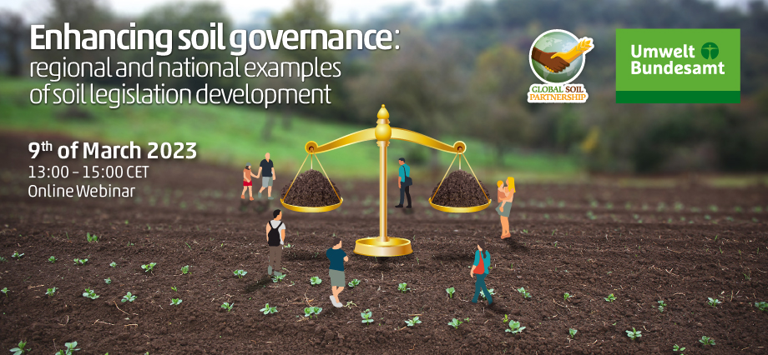

Enhancing soil governance: regional and national examples of soil legislation development
Agenda & concept note | Recordings of the webinar | Webinar Report

. 13:00-13:10 | OPENING REMARKS
Mr Lifeng Li, Director of Land and Water Division, FAO
Ms Lilian Busse, Vice President of the German Environment Agency (UBA)
13:10–13:25 | The Black Soil Protection Law of the People's Republic of China: the importance of the legislation, the process, and the approach
Prof WANG Jian, China Agriculture University
13:25–13:40 | Proposal for a global agreement on black soils protection for global food security
Prof Ivan Vasenev, chair of the International Network on Black Soils (INBS)
13:40–13:55 | Designing a Model law for Africa: regional and national considerations
Dr Harald Ginzky, German Environment Agency
13:55–14:10 | Soil governance and sustainable agriculture in Mexico

To the FAO Webpage on this online webinar, click here

