Förderhinweis auf Englisch:

This project was funded by the Federal Environment Agency and the Federal Ministry for the Environment, Climate Action, Nature Conservation and Nuclear Safety. The funds are made available by resolution of the German Bundestag.

Insert here:
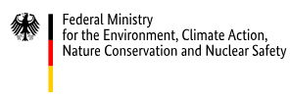 | 

The publisher is responsible for the content of this publication.

Please note the following information on using the UBA logo:
- The UBA logo may only be used for the stated purpose. A transfer to third parties is not permitted.
- The UBA logo must always be used in a size ratio of 2:1 and may not be distorted, compressed, recolored, cropped, alienated, overturned or rotated, or altered by omitting elements or using foreign typography.
- In order to ensure legibility of the logo, the minimum size must be 15 mm in width.
- If possible, the logo should be applied to a light or very high-contrast background.

Official BMUKN und UBA-Logos are send only on request at: verbaendefoerderung@uba.de

